

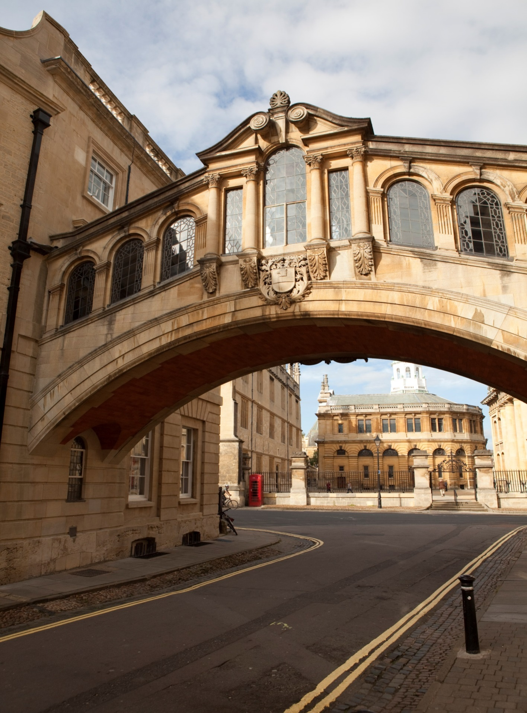

SUMMER 2015

**HERTFORD COLLEGE**

OXFORD

Beijing Normal University (Zhuhai)

at

Hertford College, Oxford

A 4 week English language and British Culture Programme



### *SUMMER 2015*

### 

### *A very warm welcome to Hertford College and to Oxford!*

### 

### 

### 

### 

### *Hertford College was founded in 1282 – it is one of the oldest of Oxford University’s 39 colleges. Located in the centre of historic Oxford, our beautiful college boasts the Bridge of Sighs, which is one of the most famous sights of the city. This is an ideal setting for students wishing to improve their language skills and knowledge of Britain and British culture.*

***Welcome to***

***Oxford!***

*MEALS*

*Meals:*

* *On* ***class days,*** *you are offered breakfast, lunch and dinner.*
* *On* ***trip days*** *you are offered breakfast, a packed lunch and dinner.*
* ***Weekend:*** *Saturday you are offered breakfast. Sunday you are offered breakfast and dinner.*
* *On* ***free-weekdays*** *(Monday-Friday) you are offered breakfast, lunch and dinner.*

*The following pages outline your academic programme*

|  |  |  |  |  |  |  |  |
| --- | --- | --- | --- | --- | --- | --- | --- |
| **WEEK ONE** | **9.00 –10.30am** |  | **11.00 – 12.30pm** |  | **2.00-4.00pm** |  | **Evening** |
| **ARRIVAL DAY**  **Day 1**  **Sunday 12th July** | * Arrive at Heathrow Airport, London. * Hertford College Residential Advisors (RAs) will meet you. * Travel to Oxford by private coach. You will stay in Oxford University Accommodation. * On arrival: Supper and welcome information. | | | | | | |
| **Day 2**  **Monday 13th July** | **Introduction to the English and British Culture programme**  **Meet the team**  **English Language assessment:** Students complete a placement test. | B  R  E  A  K | **Communicative activities:** Teachers and students meet in an informal setting for a chance to get to know each otherbefore the programme formally begins. | L  U  N  C  H | **Welcome Tea at 3.30pm:**  Sample a delicious and traditional cream tea in the splendid surroundings of Hertford College’s historic dining hall. | D  I  N  N  E  R | **Orientation:**  • Accommodation  • Facilities  • Connecting your computers to the internet |
| **Day 3**  **Tuesday 14th July** | **Academic writing 1**  An introduction to academic writing:   * Note taking * Proof reading * Introduction and conclusion * Paraphrasing | B  R  E  A  K | **Pronunciation workshop:**   * Word stress and Rhythm * Intonation in polite requests   **Architecture in Oxford**  Learn about some of the famous Buildings in Oxford. | L  U  N  C  H | **Out and About Tour of Discovery:**  A self-guided exploration of the hidden corners of Oxford. | D  I  N  N  E  R | **Cultural activities with RAs**  (Suggestion: College tour - visit some of Oxford’s most renowned colleges) |
| **Day 4**  **Wednesday 15th July** | **British Culture Topic:**  **The United Kingdom**  Deepen your knowledge of how the four constituent countries fit together to form the UK.   * Skills based activities | B  R  E  A  K | **British Culture Topic**  Continued...  **Vocabulary development** English neologisms (new words). | L  U  N  C  H | **Introduction to student presentations:**  How to plan and deliver a presentation effectively. | D  I  N  N  E  R | **Cultural activities with RAs**  (Suggestion: attend an evening lecture) |
| **Day 5**  **Thursday 16th July** | **The History of Oxford University:**  Explore the development of the leading university in the English speaking world. | B  R  E  A  K | **Oxford’s Famous Faces:** Famous people associated with Oxford | L  U  N  C  H | **An introduction to the UK’s capital:**  History, cultural highlights and interesting facts. | D  I  N  N  E  R | **Cultural activities with RAs**  (Suggestion: watch a Shakespeare play in an Oxford College garden) |
| **Day 6**  **Friday 17th July** | **Trip: London**  Enjoy a trip to the capital city and experience all the magical sights and sounds of London in the comfort and safety of your private coach. You will also visit the National Gallery. Afterwards you are free to spend the afternoon in London with your RAs. | | | | | | |
| **Day 7**  **Saturday 18th July** | **Weekend**  At the weekend you have free time. If you wish to stay in Oxford, your RAs are available for Oxford activities, such as punting, walking tours, shopping, college and museum visits.  Alternatively, some students choose to travel independently to a nearby place of interest such as:   * London * Stratford upon Avon * Warwick Castle * Cambridge * Bath * Brighton * Liverpool   These trips are not included in the programme price. Your RAs are available to offer advice and support about travel arrangements. | | | | | | |
| **Day 8**  **Sunday 19th July** | **Weekend**  Free time (as above) | | | | | | |
| **WEEK TWO** | **9.00 – 10.30am** |  | **11.00 – 12.30pm** |  | **2 – 4pm** |  | **Evening** |
| **Day 9**  **Monday 20th July** | **British Culture Topic:**  **Education**  An overview of the current system from elementary to further education.   * Skills based activities | B  R  E  A  K | **British Culture Topic**  Continued...  **Pronunciation**  Connected speech in natural English: noticing and practicing assimilation and elision. | L  U  N  C  H | **Job seeking skills 1:**  Writing successful personal statements and CVs. | D  I  N  N  E  R | Cultural activities with RAs  (Suggestion: inter-collegiate sports evening) |
| **Day 10**  **Tuesday 21st July** | **British Culture Topic:**  **Food and Drink**  British food and drink is becoming better known and understood throughout the world. Find out why and how.   * Skills based activities | B  R  E  A  K | **British Culture Topic**  Continued...  **Social English** *(Example)*  English for pubs and restaurants. | L  U  N  C  H | **Presentations Master class**  Language check  Body language and communicating with your audience. | D  I  N  N  E  R | Cultural activities with RAs  (Suggestion: go to a gig - jazz, blues, rock, pop - in Oxford with your RAs) |
| **Day 11**  **Wednesday 22nd July** | **British Culture Topic:**  **Youth Culture**  Britain has been at the forefront of youth culture since the 1950’s. Explore the world of fashion and music enjoyed by young people.   * Skills based activities | B  R  E  A  K | **British Culture Topic**  Continued...  **Social English**  Colloquial English | L  U  N  C  H | **Lecture:**  Contemporary Youth Culture | D  I  N  N  E  R | Cultural activities with RAs  (Suggestion: listen to classical music at the Sheldonian Theatre or in an Oxford College or take part in a music session with RAs) |
| **Day 12**  **Thursday 23rd July** | **British Culture topic:**  **History of modern pop music** From the 1950’s - One Direction.   * Skills based activities. | B  R  E  A  K | **Current Affairs**  Discover how newspapers capture the interest of their readers by creating effective headlines. | L  U  N  C  H | **Introduction to Bath**  Learn about the history of this beautiful city and World Heritage Site | D  I  N  N  E  R | Cultural activities with RAs  (Suggestion: party with students from other universities) |
| **Day 13**  **Friday 24th July** | Trip: Bath You will visit the Roman town of Bath. Visit the Roman Baths and also the Pump Rooms, a very elegant tearoom made famous in the eighteenth-century. Explore the streets and shops of this beautiful little city. You will be accompanied and guided by the RAs. Transport will be by private coach and you will travel back to Oxford in time for Dinner in the evening. | | | | | | |
| **Day 14**  **Saturday 25th July** | **Weekend**  Free time (as explained on day 7) | | | | | | |
| **Day 15**  **Sunday 26th July** | **Weekend**  Free time (as explained on day 7) | | | | | | |
| **WEEK THREE** | **9.00 – 10.30am** |  | **11.00 – 12.30pm** |  | **2-4pm** |  | **Evening** |
| **Day 16**  **Monday 27th July** | **British Culture Topic:**  **Customs and Beliefs**  Explore the similarities and differences in our beliefs and customs.  Skills based activities | B  R  E  A  K | **British Culture Topic**  Continued... | L  U  N  C  H | **Job Seeking Skills 2:**  Interview skills | D  I  N  N  E  R | Cultural activities with RAs  (Suggestion: visit a historic Oxford pub) |
| **Day 17**  **Tuesday 28th July** | **British Culture Topic:**  **Money and Work**  Examine the current state of the economy and the issues facing the employers and the workforce.   * Skills based activities | B  R  E  A  K | **British Culture Topic**  Continued...  **Vocabulary development**   * Related word groups | L  U  N  C  H | **Team building and leadership**  Learn how to plan and manage a successful, motivated team. | D  I  N  N  E  R | Cultural activities with RAs  (Suggestion: enjoy the famous “Oxford Blue” ice cream with your RAs in a local cafe) |
| **Day 18**  **Wednesday 29th July** | **Business in Britain:**  Case study of a successful business. | B  R  E  A  K | **Business ethics and corporate decision-making**  How companies respond to the ever-changing demands of the global marketplace. | L  U  N  C  H | **Academic Writing 2**   * Comparison/Contrast Essays * Active/passive voice in writing * References and bibliography | D  I  N  N  E  R | Cultural activities with RAs  (Suggestion: Go for a river or canal side walk with your RAs) |
| **Day 19**  **Thursday 30th July** | **The language of debate**   * Dis/agreeing * Asking for/ giving opinion * Language of persuasion | B  R  E  A  K | **Debating Skills**  Mini debate in groups | L  U  N  C  H | **Introduction to Blenheim Palace and the Cotswolds**  Built for the grandfather of Winston Churchill, this majestic palace is nestled in the hills of the stunning Cotswolds. Find out more about this landmark and the history of the area. | D  I  N  N  E  R | Cultural activities with RAs    (Suggestion: attend a British quiz or popular games night with your RAs) |
| **Day 20**  **Friday 31st July** | **Trip: Blenheim Palace and The Cotswolds**  Blenheim Palace is one of Britain’s most famous landmarks. You will take a tour of its beautiful state rooms and you will visit The Cotswolds, an area of outstanding natural beauty and picturesque villages.  You will be accompanied and guided by the RAs. Transport will be by private coach. You will be brought back to Oxford in time for dinner in the evening. | | | | | | |
| **Day 21**  **Saturday 1st August** | **Weekend**  Free time (as explained on day 7) | | | | | | |
| **Day 22**  **Sunday 2nd August** | **Weekend**  Free time (as explained on day 7) | | | | | | |
| **WEEK FOUR** | **9.00 – 10.30am** |  | **11.00 – 12.30pm** |  | **2 – 4pm** |  | **Evening** |
| **Day 23**  **Monday 3rd August** | **British Culture Topic:**  **The British Film Industry**  Find out about Britain’s rich cinematic history   * Skills based activities | B  R  E  A  K | **British Culture Topic**  Continued...  **Vocabulary Development**  Phrasal verbs | L  U  N  C  H | **Collaborative writing activity**  Work as part of a group to design and create an effective text. | D  I  N  N  E  R | Cultural activities with RAs    (Suggestion: College tour - visit some of Oxford’s most renowned colleges) |
| **Day 24**  **Tuesday 4th August** | **British Culture Topic:**  **Literature and Arts**  Britain has a long and rich literary and artistic heritage. Find out more.   * Skills based activities | B  R  E  A  K | **British Culture Topic**  Continued ...  Vocabulary Development  Idiomatic expressions | L  U  N  C  H | **Lecture:**  Oxford and Literature | D  I  N  N  E  R | Cultural activities with RAs  (Suggestion: Film night) |
| **Day 25**  **Wednesday 5th August** | **End of Course Test**  Review all language and topics covered in the programme. | B  R  E  A  K | **Fine Tuning of Presentations**  Language check  Body language and communicating with your audience. | L  U  N  C  H | **Vocabulary Development**  American vs British English | D  I  N  N  E  R | Cultural activities with RAs  (Suggestion: visit a historic Oxford pub) |
| **Day 26**  **Thursday 6th August** | **End of Course Presentations**   * Students deliver presentations in small groups before an audience. | B  R  E  A  K | **End of Course Presentations (cont.)** | L  U  N  C  H | **Presentation feedback and end of course assessment** | D  I  N  N  E  R | **GALA DINNER**  Celebrate your success at a memorable candle-lit dinner in the historic dining hall at Hertford College where you will be presented with a certificate at the end-of-course ceremony.  This is a special event so please wear smart clothes & bring your camera! |
| **Day 27**  **Friday 7th August** | **Free time** (as explained on day 7) | | | | | | |
| **Day 28**  **Saturday 8th August** | **Departure day**  You will be accompanied by the RAs in a private coach to the airport. | | | | | | |

The International Programmes Department,

Hertford College,

Catte Street,

OX1 3BW

Tel: 01865 279 356



**THEINTERNATIONAL PROGRAMMES DEPARTMENT**

**HERTFORD COLLEGE, OXFORD**