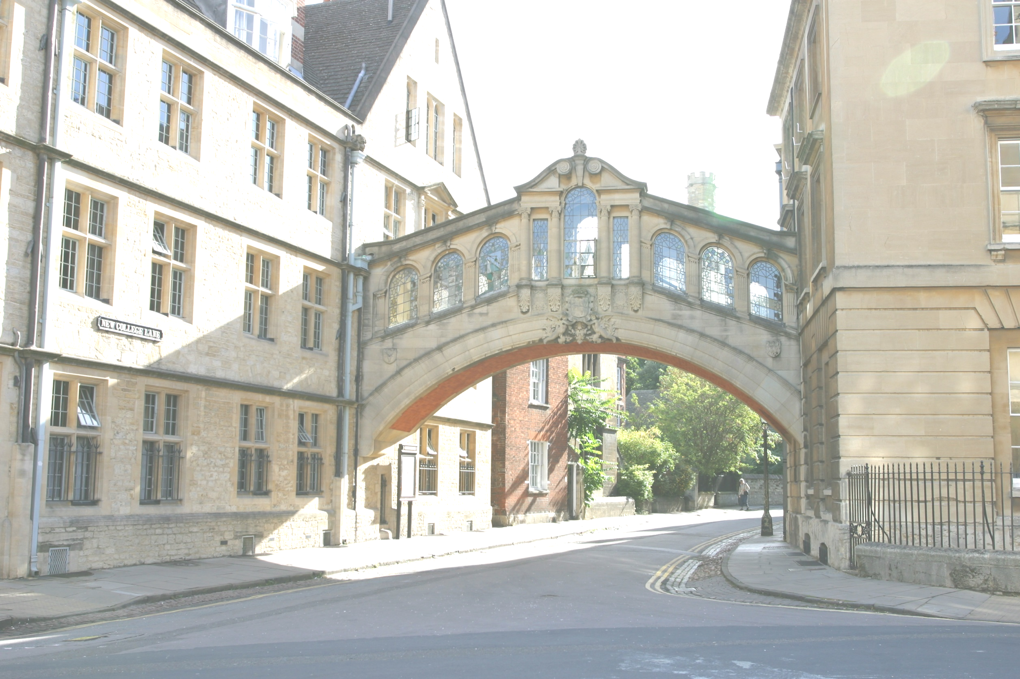

BNUZ at Hertford College, Oxford



English Language and British Culture Programme

Summer 2014


A very warm welcome to Hertford College and to Oxford!

Our team is looking forward to meeting you and helping you make the most of your stay with us in this beautiful city. The people responsible for organising your programme are:

- Julie Dearden. BA Hons Oxon, MA Oxon, MSc Oxon. (Director of International Programmes and Teacher Training)

- Andrew Hemingway BA , MA , MSc Oxon, DELTA (EFL Director of Studies)

- Hannah Gregory BA, DELTA (EFL Assistant Director of Studies)

- Jenny Yeong BA, DELTA (EFL Senior Teacher)

- Caroline Rice BA (Greater China contact, International Programmes)

- Fatjon Alliaj BA (International Programmes)

- Louise Turner (International Programmes)

Hertford College was founded in 1282 – it is one of the oldest of Oxford University’s 38 colleges. Located in the centre of historic Oxford, our beautiful college is famous for the Bridge of Sighs, which is one of the most wonderful sights of the city. This is an ideal setting for students wishing to improve their language skills and knowledge of Britain and British culture.

Over the past ten years, we have been providing high quality English Language programmes for a wide variety of international students. We offer a prestigious and stimulating learning environment, the highest standards of programme design and organisation, and a dedicated and professional team who ensure your stay with us is fulfilling and enjoyable.

Our teachers and lecturers are all well-qualified and have years of experience teaching students from all over the world. Your level will be assessed on arrival, and you will be carefully monitored throughout the programme so that you can be sure of making the maximum possible progress.

The following information will help you during your stay here. We are sure that you will enjoy your time here in Oxford.

Welcome to Oxford!

Itinerary and programme information

The following is the itinerary for an advanced level group. Students will be tested and placed in an appropriate level group on arrival. We will arrange classes ranging from advanced level to intermediate level, as required.

You are taught in small classes. This creates a lively group atmosphere whilst allowing your own individual needs to be met. Classes are taught communicatively and entirely in English.

Course book: New English File

COURSE AIMS

For the student:

- To communicate effectively in English
- To develop a high level of grammatical competence
- To improve pronunciation / intonation in key areas
- To discover Oxford
- To learn about British society and culture
- To deliver a presentation in English
- To learn in an inspiring and supportive environment
Arrival day  Day 1  Sunday 29th June | The Residential Advisors (RAs) will meet you at the airport, accompany and assist you during your stay.  The RAs will ensure that you have a fun and safe time while you are in Oxford. All RAs are current Oxford undergraduates and will help you to settle in as well as giving you the opportunity to make friends and practise your English. In the evenings, they will organise a varied programme including visits and activities (your participation is optional). Typical activities include: sports evenings, punting, visits to colleges, games and DVD evenings and cookery sessions. Some sessions can have an academic focus, such as ‘debate night’ or a ‘public speaking competition’ with students from other universities. The RAs will also be happy to help you plan your free time. They are looking forward to meeting you!  - Arrive at Heathrow Airport, London.  - Hertford College Residential Advisors (RAs) will meet you.  - Travel to Oxford by private coach. You will stay in Oxford University Accommodation.  - On arrival: supper and welcome information.
Week ONE | 9.00 – 10.30am |  | 11.00 – 12.30pm |  |  |  |  |  |  |  |  | 2 – 4pm |  |  |  |  |  |  |  |  |  |  |  |  |  |  |  | Evening
First teaching day  Day 2  Monday 30th June | Introduction to the English and British Culture programme  Meet the team  English Language assessment: students complete a placement test. | B  R  E  A  K | Speaking activities: Teachers and students meet in an informal setting for a chance to get to know each other before the programme formally begins. |  |  |  |  |  |  |  | L  U  N  C  H | Welcome Tea at 3.30pm:  Sample a delicious and traditional cream tea in the splendid surroundings of Hertford College’s historic dining hall. |  |  |  |  |  |  |  |  |  |  |  |  | D  I  N  N  E  R |  |  | Orientation:  - Accommodation  - Facilities  - Connecting your computers to the internet
Day 3  Tuesday 1st July | Exploring Ways to learn English  Language Learning Contract  Writing workshop  (Example)  - How to summarise and paraphrase: techniques and exercises | B  R  E  A  K | Pronunciation workshop: (Example)  - Word stress and Rhythm  - Intonation in polite requests  Architecture in Oxford  Famous Oxford Buildings |  |  |  |  |  |  |  | L  U  N  C  H | Out and About Tour of Discovery:  A self-guided exploration of the hidden corners of Oxford |  |  |  |  |  |  |  |  |  |  |  |  | D  I  N  N  E  R |  |  | Cultural activities with RAs  (Suggestion: College tour - visit some of Oxford’s most renowned colleges)
Day 4  Wednesday 2nd July | Language Focus: (Example)  - Advanced reading and speaking skills  - Vocabulary development: English neologisms (new words) | B  R  E  A  K | The History of Oxford University: explore the development of the leading university in the English speaking world. |  |  |  |  |  |  |  | L  U  N  C  H | Oxford’s Famous Faces: famous people associated with Oxford  British Society and Culture:  Students vote for their favourite British Culture topics to study during the British Culture afternoon sessions – one topic to be taught per afternoon session. Popular topics include: Sports, The Media, Food and Drink, Architecture, Traditional and Modern Music, The History of English, English Literature, Youth Culture, Politics, Festivals, The World of Work, The Monarchy.  - Food and drink in Britain |  |  |  |  |  |  |  |  |  |  |  |  | D  I  N  N  E  R |  |  | Cultural activities with RAs  (Suggestion: attend an evening lecture)
Day 5  Thursday 3rd July | Weekly consolidation:  trouble shooting of areas of difficulty | B  R  E  AK | Introduction to student presentations  - How to plan and deliver a presentation effectively |  |  |  |  |  |  |  | L  U  N  C  H | Shakespeare: his life and works (this session will set the context for the trip to Stratford tomorrow) |  |  |  |  |  |  |  |  |  |  |  |  | D  I  N  N  E  R |  |  | Cultural activities with RAs  (Suggestion: watch a Shakespeare play in an Oxford College garden)
Day 6  Friday 4th July | Trip to London: Enjoy a trip to the capital city and experience all the magical sights and sounds of London in the comfort and safety of your private coach. You will also visit the National Gallery. Afterwards you are free to spend the afternoon in London with your RAs.
Day 7  Saturday 5th July | Weekend: At the weekend you have free time. If you wish to stay in Oxford, your RAs are available for Oxford activities, such as punting, walking tours, shopping, college and museum visits.  Alternatively, some students choose to travel independently to nearby place of interest such as:  - London  - Stratford upon Avon  - Warwick Castle  - Cambridge  - Bath  - Brighton  - Liverpool  These trips are not included in the programme price  Your RAs are available to offer advice and support about travel arrangements.
Day 8  Sunday 6th July | Weekend: Free time (as above)
Week TWO | 9.00 – 10.30am |  |  |  |  | 11.00 – 12.30pm |  |  |  |  |  |  |  |  |  | 2 – 4pm |  |  |  |  |  |  |  |  |  |  |  | Evening
Day 9  Monday 7th July | Weekly Test  (to review all language and topics covered last week)  Language focus:  - Advanced reading activity  - Grammar session: (Example) discourse markers, adverbs and adverbial expressions |  |  | B  R  E  A  K | Workplace English -  Job seeking skills: (Example)  - Applying for a job: Writing successful personal statements and CVs |  |  |  |  |  |  |  | L  U  N  C  H |  | British Culture: (Example)  - Society, family and class |  |  |  |  |  |  |  | D  I  N  N  E  R |  |  |  |  | Cultural activities with RAs  (Suggestion: inter-collegiate sports evening)
Day 10  Tuesday 8th July | Language Focus:  - Advanced level listening activities  - Idiomatic expressions |  |  | B  R  E  A  K | Newspaper headline slesson: discover how newspapers capture the interest of their readers by creating effective headlines. |  |  |  |  |  |  |  | L  U  N  C  H |  |  | British Culture: (Example)  - The English Monarchy |  |  |  |  |  |  | D  I  N  N  E  R |  |  |  |  | Cultural activities with RAs  (Suggestion: go to a gig - jazz, blues, rock, pop - in Oxford with your RAs)
Day 11  Wednesday 9th July | Pronunciation workshop: (Example)  - Connected speech in natural English: noticing and practicing assimilation and elision |  |  | B  R  E  A  K | Advanced level presentation English:  Advanced presentation preparation:  - Language check  - Body language and communicating with your audience |  |  |  |  |  |  |  | L  U  N  C  H |  |  | British Culture: (Example)  - The media and communication |  |  |  |  |  |  | D  I  N  N  E  R |  |  |  |  | Cultural activities with RAs  (Suggestion: listen to classical music at the Sheldonian Theatre or in an Oxford College or take part in a music session with RAs)
Day 12  Thursday 10th July | Academic Writing workshop: (Example)  - Comparison/Contrast Essays  - Discursive writing |  |  | B  R  E  A  K | Academic debating skills:  (Example)  - The language of debate: expressing your opinion and comments  - Mini debate in groups |  |  |  |  |  |  |  | L  U  N  C  H  H |  |  | Bath and Stonehenge:  - The beautiful town of Bath and the mysteries surrounding Stonehenge:  This session will set the context for the trip tomorrow |  |  |  |  |  |  | D  I  N  N  E  R  R |  |  |  |  | Cultural activities with RAs  (Suggestion: party with students from other universities)
Day 13  Friday 11th July | Trip to Blenheim Palace and the Cotswolds: Trip: Blenheim and The Cotswolds:  Blenheim Palace is one of Britain’s most famous landmarks. After a guided tour of its beautiful rooms you will visit The Cotswolds, an area of outstanding natural beauty and picturesque villages.  You will be accompanied and guided by the RAs. Transport will be by private coach. You will be brought back to Oxford  in time for dinner in the evening.  You will be accompanied and guided by the RAs. Transport will be by private coach. And you will be brought back to Oxford in time for dinner in the evening.
Day 14  Saturday 12th July | Weekend: Free time (as explained on day 7)
Day 15  Sunday 13th July | Weekend: Free time (as explained on day 7)
Week THREE | 9.00 – 10.30am |  |  |  |  |  |  |  | 11.00 – 12.30pm |  |  |  |  |  |  |  |  |  |  | 2-4pm |  |  |  |  |  |  |  |  |  |  | Evening
Day 16  Monday 14th July | Weekly Test  (to review all language and topics covered last week)  Language Focus:  - Key phrasal verbs |  |  |  |  |  | B  R  E  A  K | Language Focus:  - Collaborative writing activity: work as part of a group to design and create an effective text |  |  |  |  |  |  |  |  | L  U  N  C  H |  |  |  | British Culture:  (Example)  - The History of Great Britain |  |  |  |  | D  I  N  N  E  R |  |  |  | Cultural activities with RAs  (Suggestion: visit a historic Oxford pub)
Day 17  Tuesday 15th July | Language Focus:  - Pronunciation trouble shooting workshop – recognise your own areas of difficulty |  |  |  |  |  | B  R  E  A  K | Workplace English:  - Interpersonal communication skills |  |  |  |  |  |  |  |  | L  U  N  C  H |  |  | British Culture:  (Example)  - Highlights of the British Museum |  |  |  |  |  | D  I  N  N  E  R |  |  |  | Cultural activities with RAs  (Suggestion: enjoy the famous “Oxford Blue” ice cream with your RAs in a local cafe)
Day 18  Wednesday 16th July | Language Focus:  - Speculation and deduction  - Expressing your opinion and comments |  |  |  |  |  | B  R  E  A  K | An introduction to UK cities: history, cultural highlights and interesting facts. |  |  |  |  |  |  |  |  | L  U  N  C  H |  |  |  | Business in Britain:  Case study of a successful business |  |  |  |  | D  I  N  N  E  R |  |  |  | Cultural activities with RAs  (Suggestion: Go for a river or canal side walk with your RAs)
Day 19  Thursday 17th July | Weekly consolidation: a chance to explore language queries, as a group |  |  |  |  |  |  | Advanced presentation techniques and language |  |  |  |  |  |  |  |  |  |  |  |  | Blenheim Palace and the Cotswolds (this will set the context for the trip tomorrow) |  |  |  |  |  |  |  |  | Cultural activities with RAs  (Suggestion: attend a British quiz or popular games night with your RAs)
Day 20  Friday 18th July | Trip: Warwick Castle and Stratford: See the Castle and its dungeon, towers, Great Hall and gardens. Also, witness demonstrations of archery, medieval armoured combat, falconry, jousting and the firing of a replica trebuchet (very exciting). Stratford is both the birthplace, and burial place of Shakespeare. In Stratford you can tour the house where Shakespeare was born, see where he was educated and visit his tomb in Holy Trinity Church. A fee is charged to visit both Shakespeare’s birthplace and tomb. In Stratford you can also see the theatres used by the Royal Shakespeare Company.  Transport will be by private coach. You will be brought back to Oxford  in time for dinner in the evening.
Day 21  Saturday 19th July | Weekend: Free time (as explained on day 7)
Day 22  Sunday 20th July | Weekend: Free time (as explained on day 7)
Week FOUR | 9.00 – 10.30am |  |  |  |  |  |  |  |  | 11.00 – 12.30pm |  |  |  |  |  |  |  |  |  |  |  | 2 – 4pm |  |  |  |  |  |  | Evening
Day 23  Monday 21st July | Weekly Test  (to review all language and topics covered over the last 3 weeks)  Idioms and neologisms – English as a living language |  |  |  |  |  | B  R  E  A  K |  |  | Language Focus:  - Adding emphasis in both formal and informal English |  |  |  |  |  |  |  |  | L  U  N  C  H |  |  | British Culture:  (Example)  - Creative arts and culture  Literature in Oxford:  An introduction to some of the many famous authors of Oxford |  |  |  | D  I  N  N  E  R |  |  |  | Cultural activities with RAs  (Suggestion: College tour - visit some of Oxford’s most renowned colleges)
Day 24  Tuesday 22nd July | Language Focus:  Grammar session:  - Common phrasal verbs and when to use them |  |  |  |  |  | B  R  E  A  K |  |  | Workplace English -  Job seeking skills:  - How to perform well at a job interview |  |  |  |  |  |  |  |  | L  U  N  C  H |  |  | British Culture: (Example)  - The British Education System: Primary and Secondary Education |  |  |  | D  I  N  N  E  R |  |  |  | Cultural activities with RAs  (Suggestion: Film night)
Day 25  Wednesday 23rd July | Language Focus:  - Politeness and appropriacy |  |  |  |  |  | B  R  E  A  K |  |  | Language Focus:  Advanced presentation techniques and language |  |  |  |  |  |  |  |  | L  U  N  C  H |  |  | British Culture: (Example)  - Youth culture |  |  |  | D  I  N  N  E  R |  |  |  | Cultural activities with RAs  (Suggestion: visit a historic Oxford pub)
Day 26  Thursday 24th July | End of Course Presentations  - Students deliver presentations in small groups before an audience  . |  |  |  |  |  | B  R  E  A  K |  |  | End of Course Presentations (cont) |  |  |  |  |  |  |  |  | L  U  N  C  H  H |  |  | Presentation feedback and end of course assessment |  |  |  | D  I  N  N  E  R  R |  |  |  | GALA DINNER  Celebrate your success at a memorable candle-lit dinner in the historic dining hall at Hertford College where you will be presented with a certificate at the end-of-course ceremony.  This is a special event so please wear smart clothes & bring your camera!
Day 27  Friday 25th July | Free time (as explained on day 7)
Day 29  Saturday 26th July | Departure day: You will be accompanied by the RAs in a private coach to the airport.

Meals:

- On class days, you are offered breakfast, lunch and dinner.
- On trip days you are offered breakfast, a packed lunch and dinner.
- Weekend: Saturday you are offered breakfast. Sunday you are offered breakfast and dinner.
- On free-weekdays (Monday-Friday) you are offered breakfast, lunch and dinner.

