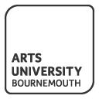

English plus British Culture and Arts
Summer Course

For Beijing Normal University Zhuhai Students

at

Arts University Bournemouth
The No. 1 Creative University in the UK

Introduction

The Arts University Bournemouth is one of the UK’s leading specialist creative universities.
Voted the No 1 Creative University in 2012, by students it is the ideal place to learn British culture
and develop their English skills.

Since 1885, AUB has offered high quality specialist education for students in art, design,
media and performance; we are a world respective university with award winning courses and
staff.

Our summer course has been designed to help you understand British culture
and appreciate British art and design, and at the same time practice your English language
skills in the country where the language originated.

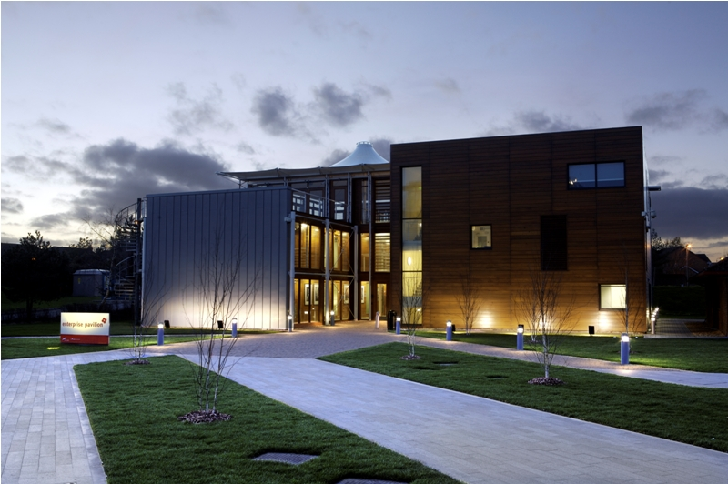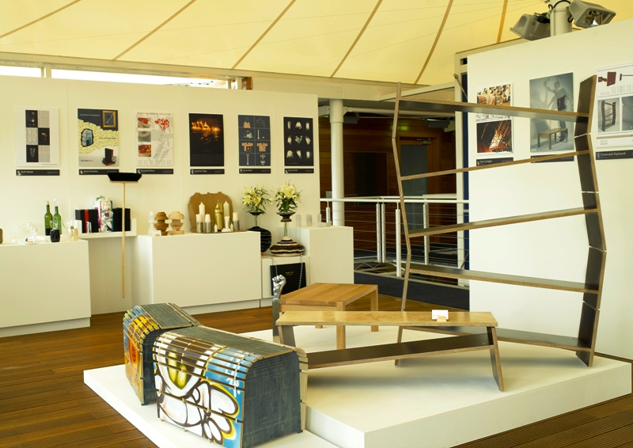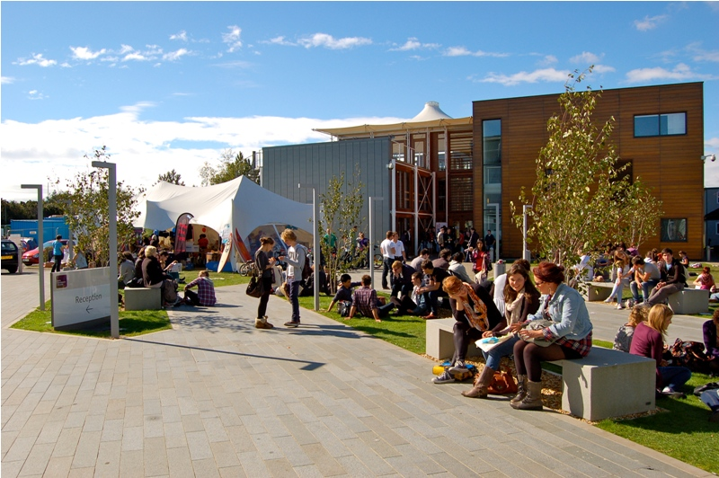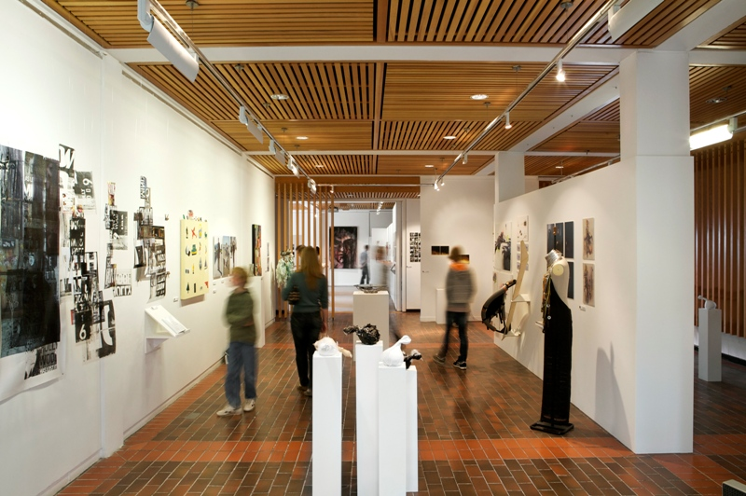 .

Summer Course: English plus British Culture and Arts

3 weeks

This course provides an exciting opportunity to explore British culture and practice language skills, learning through projects at our state-of-the-arts university in the UK.

A series of short projects, taught in our state-of-the-art studios and specialist workshops, will
provide students with a portfolio of work demonstrating their understanding and learning.

The course also features a series of study visits to museums and landmark buildings both locally and nationally to enable students to explore the wider context in which British arts and culture can be explained.

Daily Schedule:

Breakfast: 08:30 – 9:15
Morning Session: 09:30 – 12:30 (with a 15 minutes break)
Lunch: 12:30 – 14:00
Afternoon Session: 14:00 – 17:00 (with a 15 minutes break)

Base room
A dedicated room with internet access for students to use on campus will be available every evening to help students continue their learning.
Free Time
Students will have options to either relax on days of timetabled ‘Free time’, or can choose to take part in the many tours available from Bournemouth.

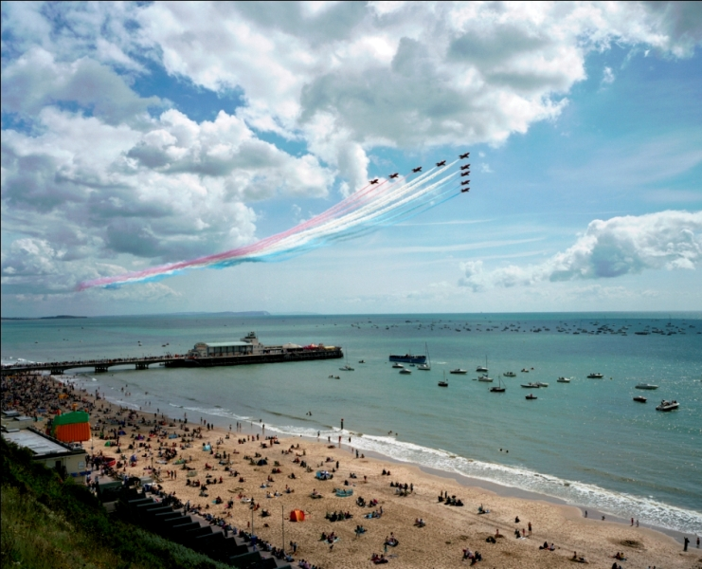

Mordern Campus

Library – AUB library is the largest library in south England. With a team of professional staff and wide range of resources focussed on the study of art, design, media and performance we aim to help all students at Arts University Bournemouth to realise their full potential both during their studies and beyond.

Gallery – The Gallery at Arts University Bournemouth offers a unique space in the South West for the arts including design, media and performance.

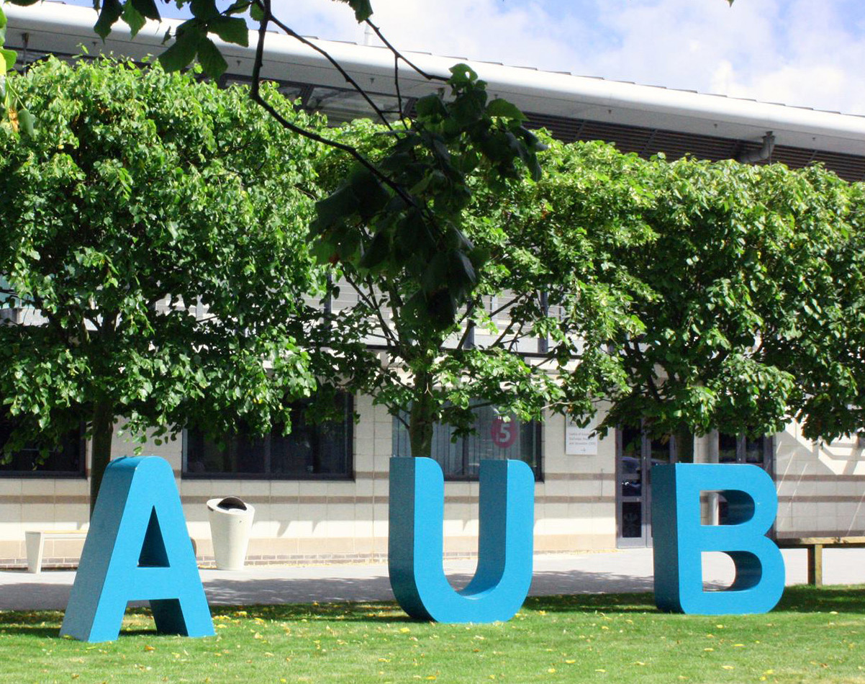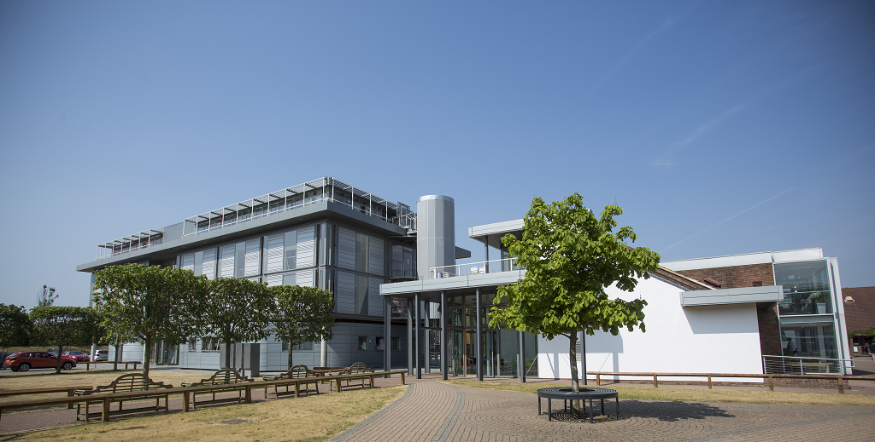

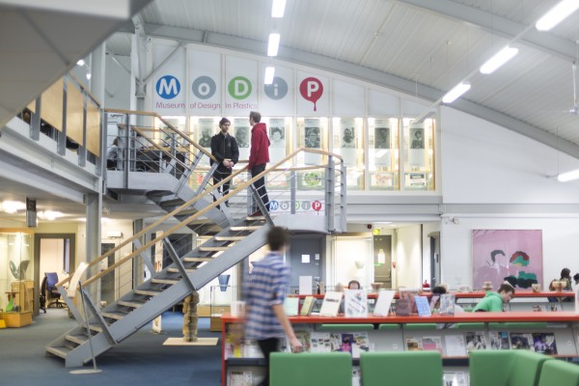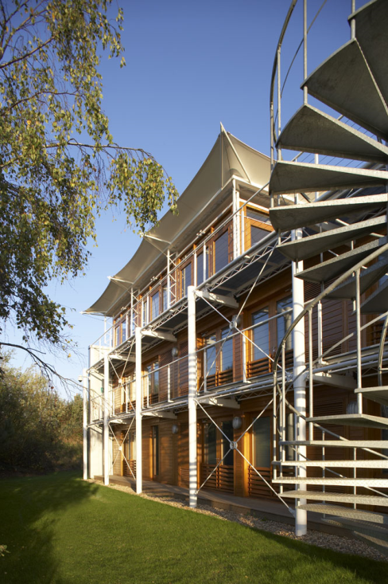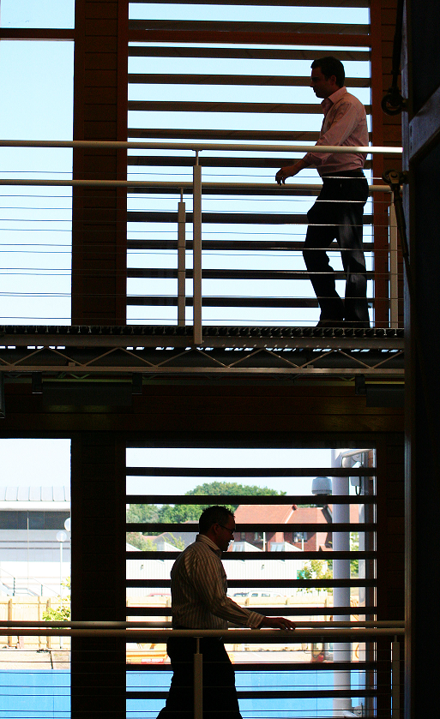

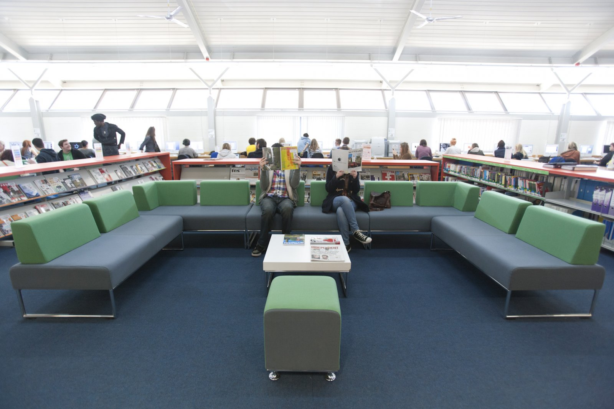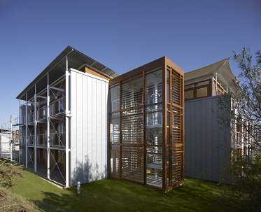

Timetable Examples:

3 weeks: any 3 weeks start on 13.07.2015 (or other dates on request)
Day 1  Sunday | Heathrow Airport - Bus Airport transfer to AUB accommodation  Introduction to accommodation  抵达英国，入住伯恩茅斯
 | Morning  09:30 – 12:30 |  | Afternoon  14:00 – 17:00
Day 2  Monday | Welcome, Culture awareness and campus tour  小学期&暑期课程开营式及校园参观 |  | Bournemouth visit  伯恩茅斯游览
Day 3  Tuesday | English (Britain/ Bournemouth Introduction)  英语 - 英国概况及伯恩茅斯市介绍 |  | Arts and Culture in Britain  英国文化艺术概论
Day 4  Wednesday | London landmarks visit 伦敦地标及著名景点参观（大本钟，议会，塔桥，白金汉宫，伦敦眼等）
Day 5  Thursday | English (Britain education)  英语 - 英国教育体系 |  | Photography workshop  摄影工作坊
Day 6  Friday | British Architecture Appreciation  英国建筑鉴赏 |  | local theatre visit  当地文化场所参观
Day 7  Saturday | Oxford visit牛津一日游
Day 8  Sunday | Free day (group can go to London or other cities independently)  自由活动（伯恩茅斯艺术大学可派学生代表全程陪同）
Day 9  Monday | English (British food/ table etiquette)  英语 - 英国饮食文化，餐桌礼仪 |  | British Film  英国电影
Day 10  Tuesday | English (British Festival)  英语 - 英国节日 |  | 3 Cultural Systems: America, UK and Europe  三种文化体系：美国，英国，欧洲大陆
Day 11  Wednesday | Bath and Stonehenge visit 巴斯和巨石阵一日游（罗马浴场，新月楼，时尚博物馆，埃文河等）
Day 12  Thursday | British Fashion  英国时尚 |  | Fashion and Vintage visit  英国时尚及复古店参观
Day 13  Friday | Make up – special effects  化妆-特效 |  | Presentation and pronunciation skills  演讲及发音技巧
Day 14  Saturday | Jurassic Coast visit 侏罗纪海岸一日游（世界文化遗产）
Day 15  Sunday | Free day (group can go to London or other cities independently)  自由活动（伯恩茅斯艺术大学可派学生代表全程陪同）
Day 16  Monday | Big events planning and management  大型活动策划管理 | Student exercise – venues, events and mood boards 学生练习‘情绪板’
Day 17  Tuesday | English (Museums in England)  英语 - 英国博物馆 | Cultural and creative events management  文化及创意产业管理
Day 18  Wednesday | London museums visit  伦敦博物馆一日游（大英博物馆，V&A博物馆等）
Day 19  Thursday | English (British Music)  英语 - 英国音乐 | Graphic design workshop  平面设计工作坊
Day 20  Friday | Make up – fashion or facepainting  化妆-时尚或画脸艺术 | Farewell lunch, Certificates presentation  欢送午餐，颁发证书
Day 21  Saturday | Departure from AUB to London Airport  返回祖国

Educational Visits

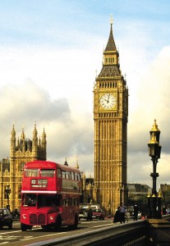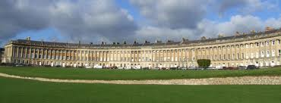
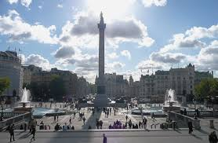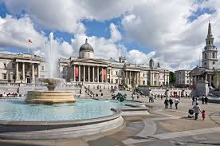

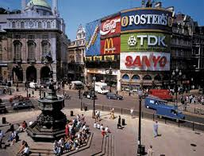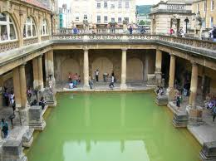

Bournemouth – United Kingdom

Bournemouth has one of the most vibrant and cosmopolitan social scenes outside of London, making it one of the best student towns in the country. It has all the attractions and appeal of a large town without the disadvantages of big city life. With seven miles of golden sands and sparkling sea, Bournemouth is a safe town for students to enjoy a truly British experience in one of the most beautiful cities in the country.

Bournemouth, one of Britain's most popular seaside resorts, is a lively university town just over an hour and a half away from London. It has a mild climate, 12 kilometres of sandy beaches (awarded the prestigious Blue Flag for cleanliness), over 800 hectares of beautiful parks, gardens and extensive leisure facilities. It has a wide variety of shops, stores and boutiques, and an exciting choice of theatres, cinemas, concert halls and clubs. Its many restaurants, pubs and cafes offer truly international cuisine. Equally important, the town offers superb facilities for almost every kind of sport.

Places to see. Outside the town, the choice is equally extensive. Poole Harbour is close by, as is the famous Dorset coastal path - part of the World Heritage Coast. The surrounding area is on we of outstanding natural beauty, boasting English Heritage sites as well as picturesque towns and villages. The Isle of Purbeck and the Isle of Wight are easily accessible; and such historic sights as the city of Winchester, the ancient monument at Stonehenge and the New Forest National Park are close at hand.

Bournemouth and the Arts University provide the perfect combination for a rewarding stay in England - and the ideal setting for study and recreation.

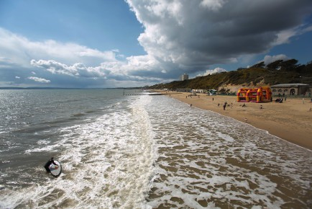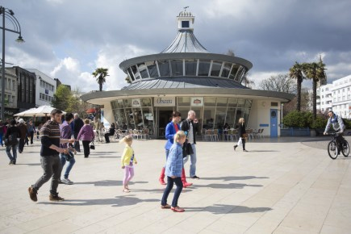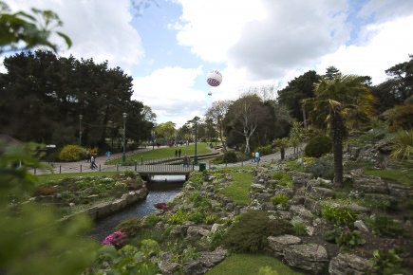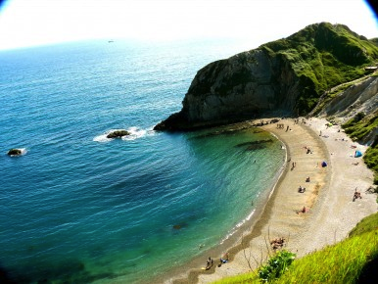

AUB Accommodation

The AUB brand new Halls of Residence are located within walking distance of Bournemouth Town Centre and beach. Regular buses take students from outside the Halls of Residence to the university campus; a short 10 minute bus ride.

The accommodation comprises:

- Single study bedroom with private en suite bathroom
- Large shared kitchens equipped with all appliances and cooking facilities
- Laundry Facilities
- Lockable storage areas
- Payphones
- Outside restaurants, bus/train station (5 minutes walk), beach, shops, etc

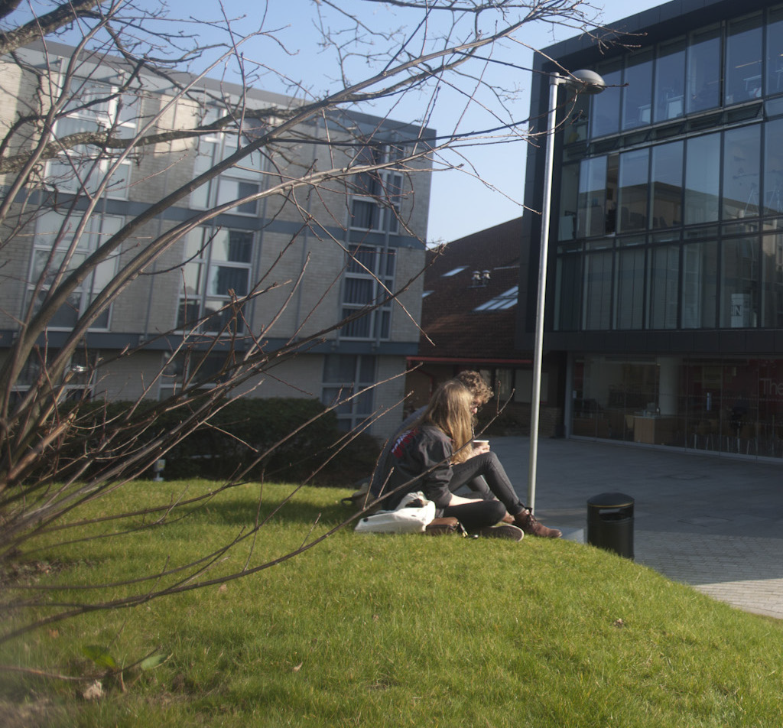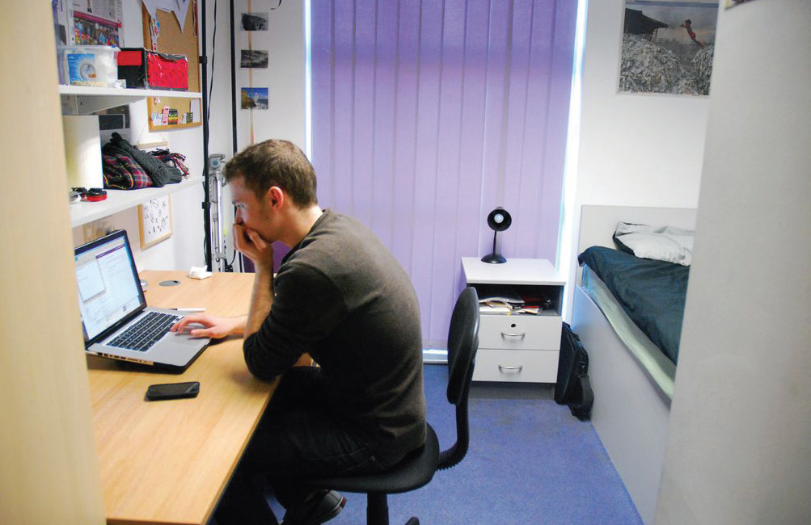

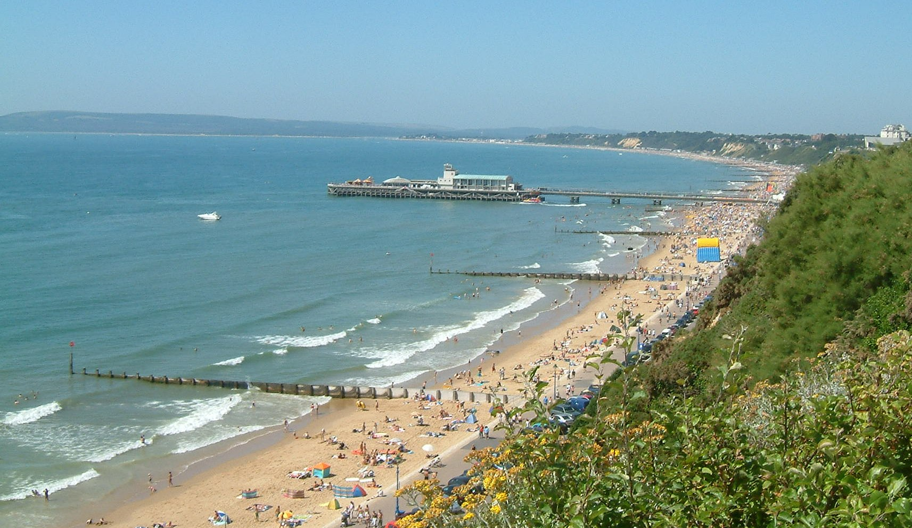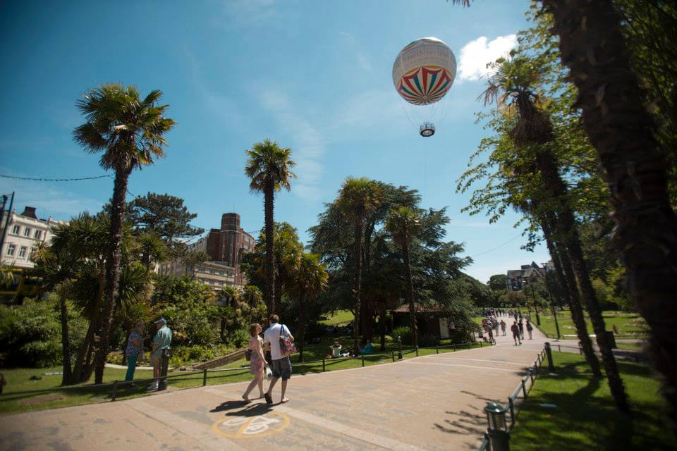

Course Fees

Fees including:

- Tuition and Material fees

- AUB Halls of Residence accommodation

- Breakfast and lunch on campus Monday to Friday

- Wi-Fi/Internet across AUB campus and access to AUB Library resources

- Airport transfers for group from and to a London Airport

- Certificate

- Lectures

- Workshops

- Educational visits

Total £ 2,150 per student for 3 weeks
(price base on group of 15 students plus)

For booking or more information contact Miao Judge on
+44(0)1202 85 3604 or by email mjudge@aub.ac.uk

